**Les Quennevais School SEND Information Report 2016-17**

At Les Quennevais School, our guiding principle is one of inclusion. We aim to identify and break down all possible barriers to learning for students with or without special educational needs and disabilities. This is achieved through early identification and appropriate support and intervention throughout their school careers.

We value all the students at Les Quennevais equally and ensure that each student has access to a broad, balanced curriculum which is fully differentiated to meet their needs and abilities. We aim to offer high quality guidance, support and intervention to ensure that the needs of all our students are met, through the Learning Support Department and Guidance team, thus ensuring a successful transition into adulthood and the world of further education, training or work. At Les Quennevais we operate a whole-school approach to meeting the needs of students with SEND (Special Educational Needs and Disability). All teachers within Les Quennevais are teachers of students with SEND, and the Learning Support Department and its staff are committed to supporting these students with special educational needs so that they can learn alongside their peers.

The Learning Support Team, managed by the Director of Inclusion, aim to not just meet the needs of students with SEND, but to encourage and support them to achieve more than they ever thought they could, as independently as possible. A core belief is that all students, no matter what their difficulty, can make progress from their individual starting points, and high expectations for all are part of the culture of Les Quennevais School.



**Frequently asked questions:**

**1. What types of SEN and disability are provided for within Les Quennevais School?**

The types of Special Educational Need and Disability that we provide for in the school are:

|  |  |  |  |
| --- | --- | --- | --- |
| Communication and Interaction | Cognition and Learning | Social, Emotional and Mental Health Difficulties | Sensory and/or Physical Needs |
| - Speech, Language and Communication Difficulties (this also includes children who have English as an additional language – EAL) – Autistic Scpectrum Conditions, including Asperger’s Syndrome and Social Communication problems. | - Moderate Learning Difficulties (MLD) - Specific Learning Difficulties (SpLD) including Dyslexia and Dyspraxia. | - Anxiety - Depression - Self-harming - Eating Disorders - Physical symptoms which are medically unexplained - Attention Deficit Disorder (ADD) - Attention Deficit Hyperactive Disorder (ADHD), general behavioural problems. | - Visual Impairment (VI) - Hearing Impairment (HI) - Physical Disability and medical needs. |

**2. What are the procedures for identifying children with SEND and assessing their needs?**

• All Students entering Les Quennevais School undertake baseline assessments soon after entry, and further in-school assessments may be offered for children who need a more in-depth learning profile.

• Student views are regularly sought through individual interviews and attitudinal surveys

• A comprehensive exchange of information takes place with partner primary schools.

• Teaching staff are able to access information (confidentially) regarding your child’s needs. This information is stored on the school database. Support strategies for students are planned so that teachers and support staff can make reasonable adjustments to their teaching practice. Information is forwarded regarding each student’s special educational needs or disability to the relevant subject teacher. High quality teaching is seen as the first priority to ensure student progress. The school has developed a SEND Data base (Provision Mapper) which clearly outlines the level of support that each individual child needs. In addition to this, our school systems allow us to track the progress of each student to help them to reach their full potential

**3. What arrangements have been made for consulting parent/carers of students with SEND and assessing their needs?**

•All parents are informed when their child is placed on our school SEND list and the Director of Inclusion is happy to meet, discuss and support parents/carers in working collaboratively with the school to meet their child’s needs.

• We are happy to offer individual appointments to discuss specific issues with you about your child’s progress. We encourage parents/carers to contact the school and arrange an appointment if they are worried or concerned about any aspect of their child’s learning or development.

• Parents and students are consulted in the implementation and monitoring of Individual Learning Plans

• Review Meetings, including Annual reviews for those students with a Record of Need, are held each year with parents, with informal half termly meetings where necessary.

•Reports are prepared and sent home to enable parents/carers to monitors their daughter/son’s progress

**4. What arrangements are in place for consulting young people with Special Educational Needs and involving them in their education?**

• Student progress meetings are held regularly to check their progress and welfare and to promote high expectations.

• Student opinion is sought and acted upon by means of questionnaires, surveys and informal discussions.

**5. What are the arrangements for assessing and reviewing student’s progress towards outcomes?**

•Annual Review meetings are held once a year with informal half termly meetings where necessary.

These meetings provide opportunities for parents/carers to meet with the DOI to discuss progress, review targets and set new targets.

• We are happy to offer individual appointments to discuss specific issues with you about your child’s progress.

• We encourage parents/carers to contact the school and arrange an appointment if they are worried or concerned about any aspect of their child’s learning or development. The school adopts an ‘Open Door‘ policy.

• Teacher Assessments are updated at the end of each term.

• An ongoing data capture is regularly assessed to measure the rate of progress against targets.

• Subject teacher, parent/carer and student concerns are acted upon to ensure progress is reviewed effectively.

• Data from baseline tests, Doddle and ongoing departmental assessments is regularly reviewed in order to monitor the progress of students with SEND and to plan effective intervention strategies where necessary.

• In-school assessments provide accurate information in order to review progress and outcomes.

•Information from evidence-based intervention programmes, such as Lexia, is used to monitor the impact of support and maintain expected levels of progress.

**6. What are the arrangements for supporting students in moving between phases of education?**

• During transition between primary and secondary, the Director of Inclusion, Senior Leadership team and relevant staff hold interviews with parents, teachers and SENCOs of primary schools in order to discuss your child’s needs and how best to support them as they move into secondary education.

• We will contact a wide range of specialist services who can support your child and, if appropriate, invite them to a meeting at the school to ensure that we are working in partnership to achieve the best outcomes for your child.

• We view the transition from primary to secondary school as a significant event for the students concerned, and we try to make this process as smooth as possible for them and their parents, while ensuring it is informative for all colleagues.

• Prospective students and parents are encouraged to introduce themselves at the School’s Open Evening. The SEND team also welcome meeting parents and students at other times of the year, particularly to discuss the nature of individual special needs. The Director of Inclusion will attend Year 6 reviews when invited by the primary school. During the summer term all the main feeder primary schools are visited.

• There is an options team who support the transition from KS3 to KS4

• Students for whom it is expected that transition could be problematic may be invited to take part in one our additional transition groups. This group usually focuses on those students whose SEND or raised anxieties levels about transfer are of concern.

• We also view the transition from secondary school to post 16 provision or employment as a significant event for the students concerned, and we try to make this process as smooth as possible for them and their parents, while ensuring it is informative for all colleagues. The Director of Inclusion and other relevant staff liaise closely with other schools and colleges, ensuring that individual students and possible future provisions for their needs are identified, while every effort is made to advise and support them into this next important phase of their lives.

**7 What is the approach for teaching children with SEND?**

In order to support all students, the curriculum is delivered in a variety of ways.

• All lessons within the school are differentiated in order to support the needs of all children.

• Small group and individual support is offered to students whom we feel would benefit from this.

• We understand that students learn at their own pace so we closely monitor progress using a variety of systems. Firstly, staff will record progress using the Doddle termly and within departments. However, they are able to express their concerns at any time if students are not making expected progress to their head of department, Director of Inclusion or Guidance team. There are regular opportunities to share views relating to how their child’s needs can be met, during parent meetings and annual reviews.

**8. How are staff trained to support children with SEND?**

• The Director of Inclusion attends Education Department briefings in order to keep up to date with new developments and updated practice in SEND.

• The school arranges staff training with outside agencies.

• The school receives support from the Educational Psychology Service . The Educational Psychologist meets termly with the Director of Inclusion to discuss priorities.

. • We can make referrals, with your consent, to many specialist services including CAMHS (Child and Adolescent Mental Health Service) ,SALT (Speech and Language Therapy Service), Occupational Therapists (OT) etc.

• The Director of Inclusion provides formal and informal training for all staff and offers drop in clinics and student strategy meetings for staff in order to raise awareness in specific areas.

**9 How is the effectiveness of provision evaluated?**

Provision is reviewed within the school on a regular basis and in the following ways:-

• School governors provide scrutiny and challenge to the senior leadership team.

• Parents are kept fully informed of any developments and are encouraged to complete written forms as part of the review process. In addition to this, they are invited to complete parental questionnaires.

. • Students participate in formal and informal reviews.

**10 How are children with SEND enabled to engage in social activities available to children in the wider community?**

• Extra-curricular clubs are offered to all students. Many of our SEND students are regularly engaged in a variety of activities alongside their peers.

• Students are encouraged to take a full part in the wider life of the school, including whole school productions, off island trips and sporting events.

**11 What support is available for improving emotional and social development?**

• All children participate in PSHE lessons which cover a variety of social and emotional issues which are important in the development of their social understanding.

• Visiting groups/speakers are invited into school to promote health, safety and well-being issues.

• E safety and cyber bullying is a part of PSHE and ICT lessons.

• All students participate in anti-bullying activities during the school year.

• If your child has any anxieties or concerns, our guidance support team for each year group, together with our safeguarding officers, are available to help your child.

• We aim to provide a curriculum appropriate to the needs of the students.

• We aim to maintain effective guidance, care and welfare for all members of the community.

• We strive to provide a caring and secure environment for all.

• The school offers a variety of groups and programmes designed to support emotional and social development, such as the Decider’s Course and social skills groups.

12. **How does the school involve other bodies, including health and social care, local authority support services and voluntary sector organisations in meeting the needs of children with SEND and supporting their families?**

• The school can access specialist support from Speech and Language Therapists, CAMHS, Paediatricians, and Children’s Services

• The school receives support from the Educational Psychology Service with a designated number of support hours each year.

•We can make referrals, with your consent, to many outside agencies, in order to access specialist support and advice.

. • The Director of Inclusion communicates regularly through meetings, letters and phone calls with parents, students and other professionals to ensure that SEND students are safe, supported and fully engaged in the school community.

**13. What are the arrangements for handling complaints from parent/carers of students with SEND about the provision made at the school?**

• Dialogue between parents and the school is actively encouraged in order to resolve any problems at an early stage.

• In the first instance, parents are invited into the school to discuss their concerns with the Director of Inclusion and/or Deputy Head who will endeavour to resolve the problem.

. • The Head Teacher will also be informed at the above stage and, if needed, a meeting will be arranged.

• The school has a complaints policy which can be found on the school website under ‘Policies’.

**14. Who has responsibility for SEND within Les Quennevais School?**

• All teachers are teachers of SEND under the Code of Practice, and have a responsibility to provide high quality, inclusive classroom teaching.

• The Director of Inclusion, Gillian Pickersgill, is SENCO and Additionally Resourced Centre Manager for students with Physical Needs. She is a qualified teacher with a number of SEN qualifications, including counselling, working with students with social, emotional and behavioural problems, the Hornsby Diploma in remediating dyslexia and the post-graduate National Award for SENCOs. She is also a member of the British Psychological Society and holds the Certificate of Competence in Educational Testing.

• The Learning Support Team, managed by the Director of Inclusion, consists of 3 Keyworkers who support students with physical needs, and 6 Learning Support Assistants with an additional part-time assistant in charge of in-school assessments. The team has a wide range of skills, experience and knowledge and are constantly updating these. Training has included SPELL training for Autism, various literacy approaches, first aid, safeguarding, child protection and specialist approaches such as manual handling and evacuation procedures for students with physical impairments.

**SEND Profile 2016-17**

*(All data has been taken from the Summer Term2017 Inclusion register)*

**Percentage of pupils with SEN in relation to whole school population:**

679 pupils were on roll in school last year

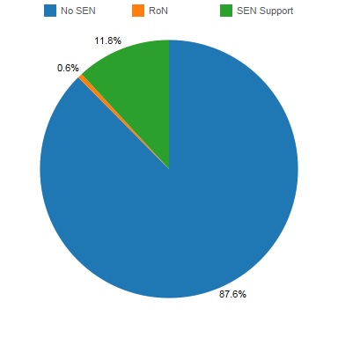

Many pupils need additional support in one or more of these areas however, of all the 45 on our Inclusion register last year, the prime reason for their additional support is detailed below.

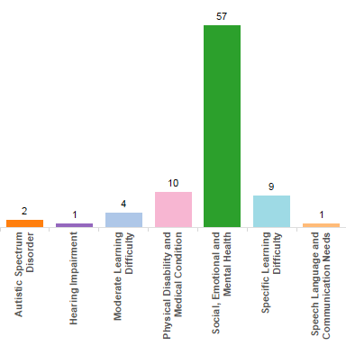

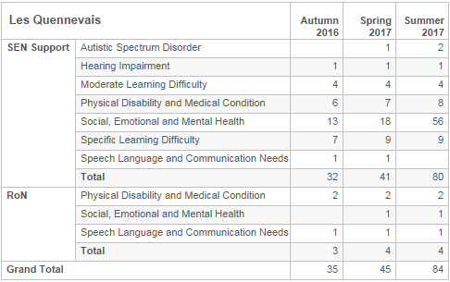

**The number of pupils identified as having SEN and recorded on the Inclusion Register , Summer Term 2017**

**Percentage of SEN by Gender (Summer Term 2017)**

(i.e. 13.9% of all boys are SEN; 10.7% of all girls are SEN)

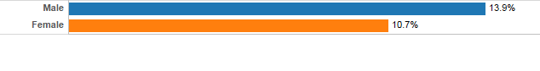

**Percentage of pupils in other vulnerable groups (Summer Term 2017)**

